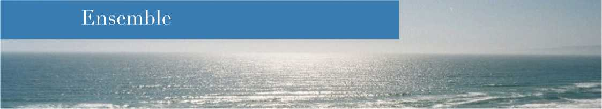

LightHouse Beach, California
A blue grey house clings to the hill... Down below the Pacific Ocean. Powerful, violent, cold, but extraordinarily beautiful. The lapping waves are a source of inspiration, sometimes of suffering, but always strong emotions. Their journey ends on a fine sandy beach.
We’re a few miles south of San Francisco, a few hundred miles north of Los Angeles, just west of the famous Silicon Valley, and a stone's throw from the famous San Andreas Fault which, one day maybe, will make the earth tremble and California disappear under the waves!
It's a place of contrasts. Nature is beautiful, terrifying sometimes, but so mesmerising. Surfing is an art here, a symbol of freedom and a way of life, sometimes dangerous.
It’s at the crossroads of all these cultures. From San Francisco, the spirit of freedom, the belief that everything is possible and that all experiences are worth trying. From Los Angeles, the sense of hype, the aesthetics of filmmaking and the importance of money. From nearby Silicon Valley, an inspirational creative spirit, a desire to build and innovate at all costs and the certainty that one idea can change the world! From the San Andreas Fault, the idea that we must be committed, right now, that we need to create opportunities and overcome obstacles.
The beach below this blue grey house is called.... LightHouse!
That's where our firm was born.
Be free. Innovate. Do it. Build. Enrich. Share. Be committed. Act. Love.
This is what inspires us every day.
This is our story. Let's share it!
Lighthouse LHLF - Law firm

